Table of Contents

Differences between Java, C and C++ 2

1. Static and dynamic programming language 2

2. Pre-Processor is required in C and C++, but not required in Java 2

3. Platform Dependent VS Platform Independent 4

# Differences between Java, C and C++

## Static and dynamic programming language

As we know that there are two types of programming language:

Dynamically typed programming language

Statically typed Programming Language

C and C++ are static programming languages, but Java is a dynamic programming language.

**Static programming language**

If any programming language allows memory allocation for primitive data types at compilation time then that programming language is called as static programming language (examples C and C++).

In C and C++ applications memory will be allocated for primitive data types at compilation time and not at runtime (off course In C and C++, calloc () and malloc () functions allows dynamic memory allocation, but in general C and C++ applications are static programming language).

**Dynamic programming language**

If any programming language allows memory allocation for primitive data types at run time then that programming language is called as dynamic programming language (example Java).

In Java applications, memory will be allocated for primitive data types at runtime only.

In Java memory is allocated for objects at runtime only, which means that memory is allocated for primitive types at run time only and not compilation time

## Pre-Processor is required in C and C++, but not required in Java

What is pre processor and where it is located.

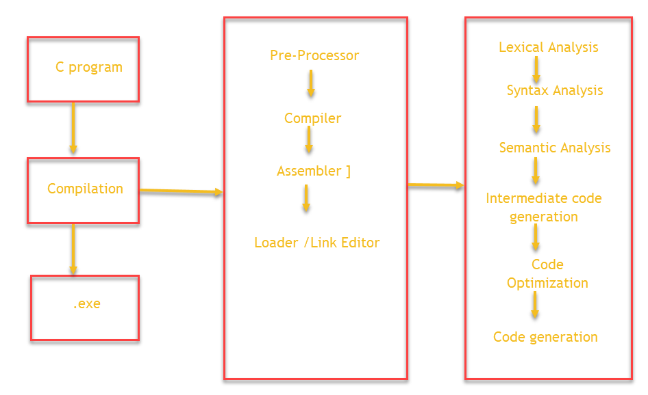

Job of preprocessor:

In C, we use header files in application

#include <stdio.h>

#include <math.h>

Preprocessor will recognize all #include statements in the C++ application.

It will check take all header file names from #include

It will search for specified / required header files in C and C++ software’s,

if the specified header files are not present then error will be generated

if the specified header files exists then preprocessor will load all the required libraries.

Preprocessor will load all the specified header files to the memory.

Loading pre-defined libraries at compilation time is called static loading.

Conclusion: In C and C++, preprocessor is required to recognize #include statements in order to load header file content to the memory.

Why pre processor is not required in Java.

Compiler responsibilities

In java classes and interfaces are in the form on packages (like java.lang.*, java.sql.*, …)

We use import statements in Java like import java.lang.*

When we compile java program, the job of the compiler is

Compiler will recognize all import statements

Compiler will take the specified packages from import statements

Compiler will go to Java software, where compiler will check whether these packages exists or not.

If packages do not exist then the compiler will raise an error

If packages exists then the compiler will not load the package content to memory.

When we execute Java application, job of JVM is

When the predefined classes and interfaces are identified by JVM, then JVM will load respective classes and interfaces into the memory.

In java applications, the predefined library is loaded by JVM as per requirement. This type of loading pre-defined libraries is called dynamic loading.

In java preprocessor is not required. In place of preprocessor, we have compiler and JVM.

<https://www.tutorialspoint.com/compiler_design/index.htm>

## Platform Dependent VS Platform Independent

C and C++ are platform dependent programming languages, but java is platform independent programming language